“On-time Care”

Problem: We would like you to design an interface for an application that will allow a hospital nursing staff to track the

medication given to a patient.

Discover Phase:

**Problem Definition**

I first mapped out the problem statement to a entity relationship diagram which highlighted the actors/people/objects involved with the system and the various actions related to them.

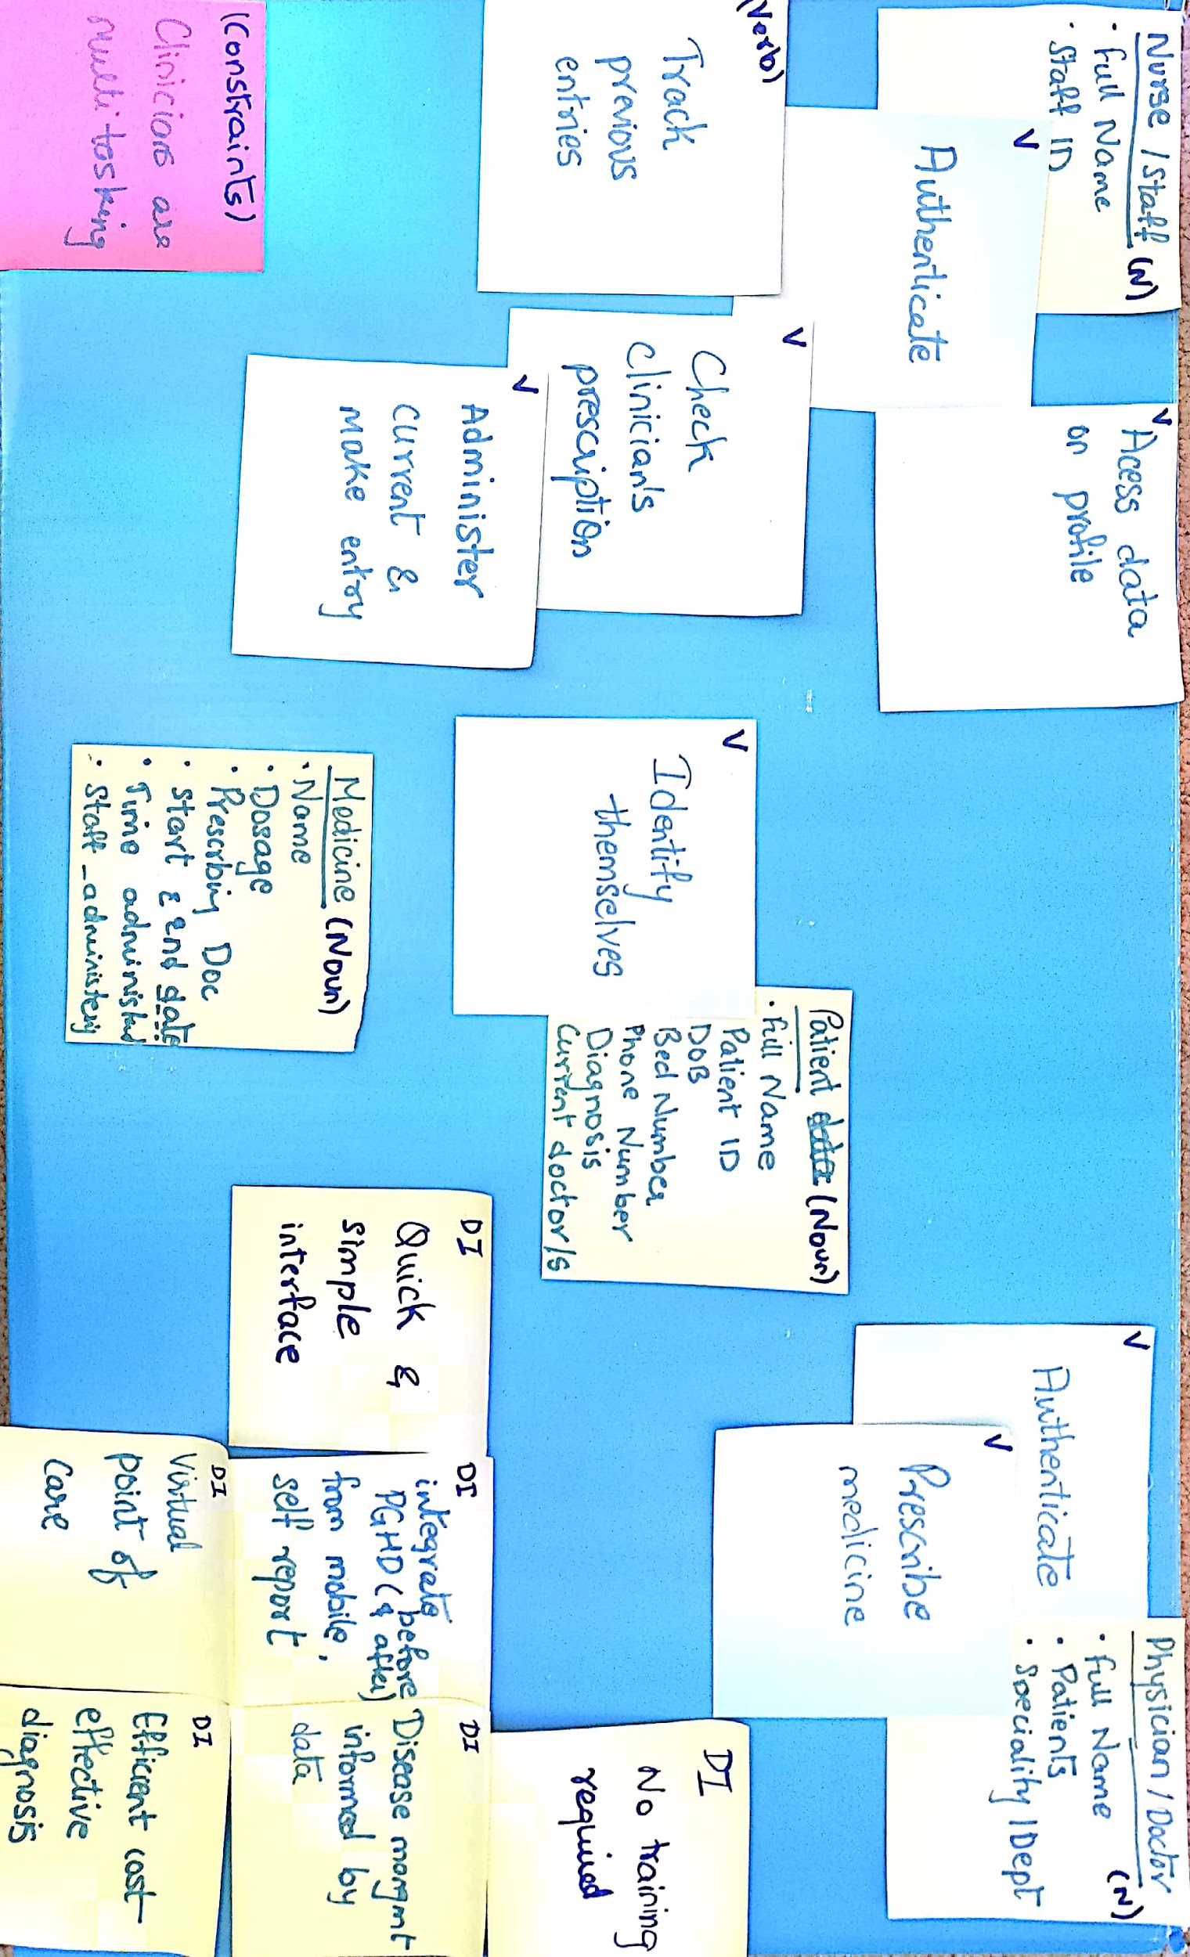

***Fig: Problem architecture***

**Scenario Mapping**

“*A nurse has just visited with a patient and administered a medication. She has accessed the page in the application*

*where she needs to enter the medication. The patient has not taken the medication before but needs to take the*

*medication 4 more times in the next 48 hours. The patient is currently taking 3 other medications. One medication is*

*for a chronic condition, and the other two medications were first administered when he arrived at the hospital*.”

To lay out the steps in the scenario, along with challenges and design ideas, I created a scenario map for the problem statement.

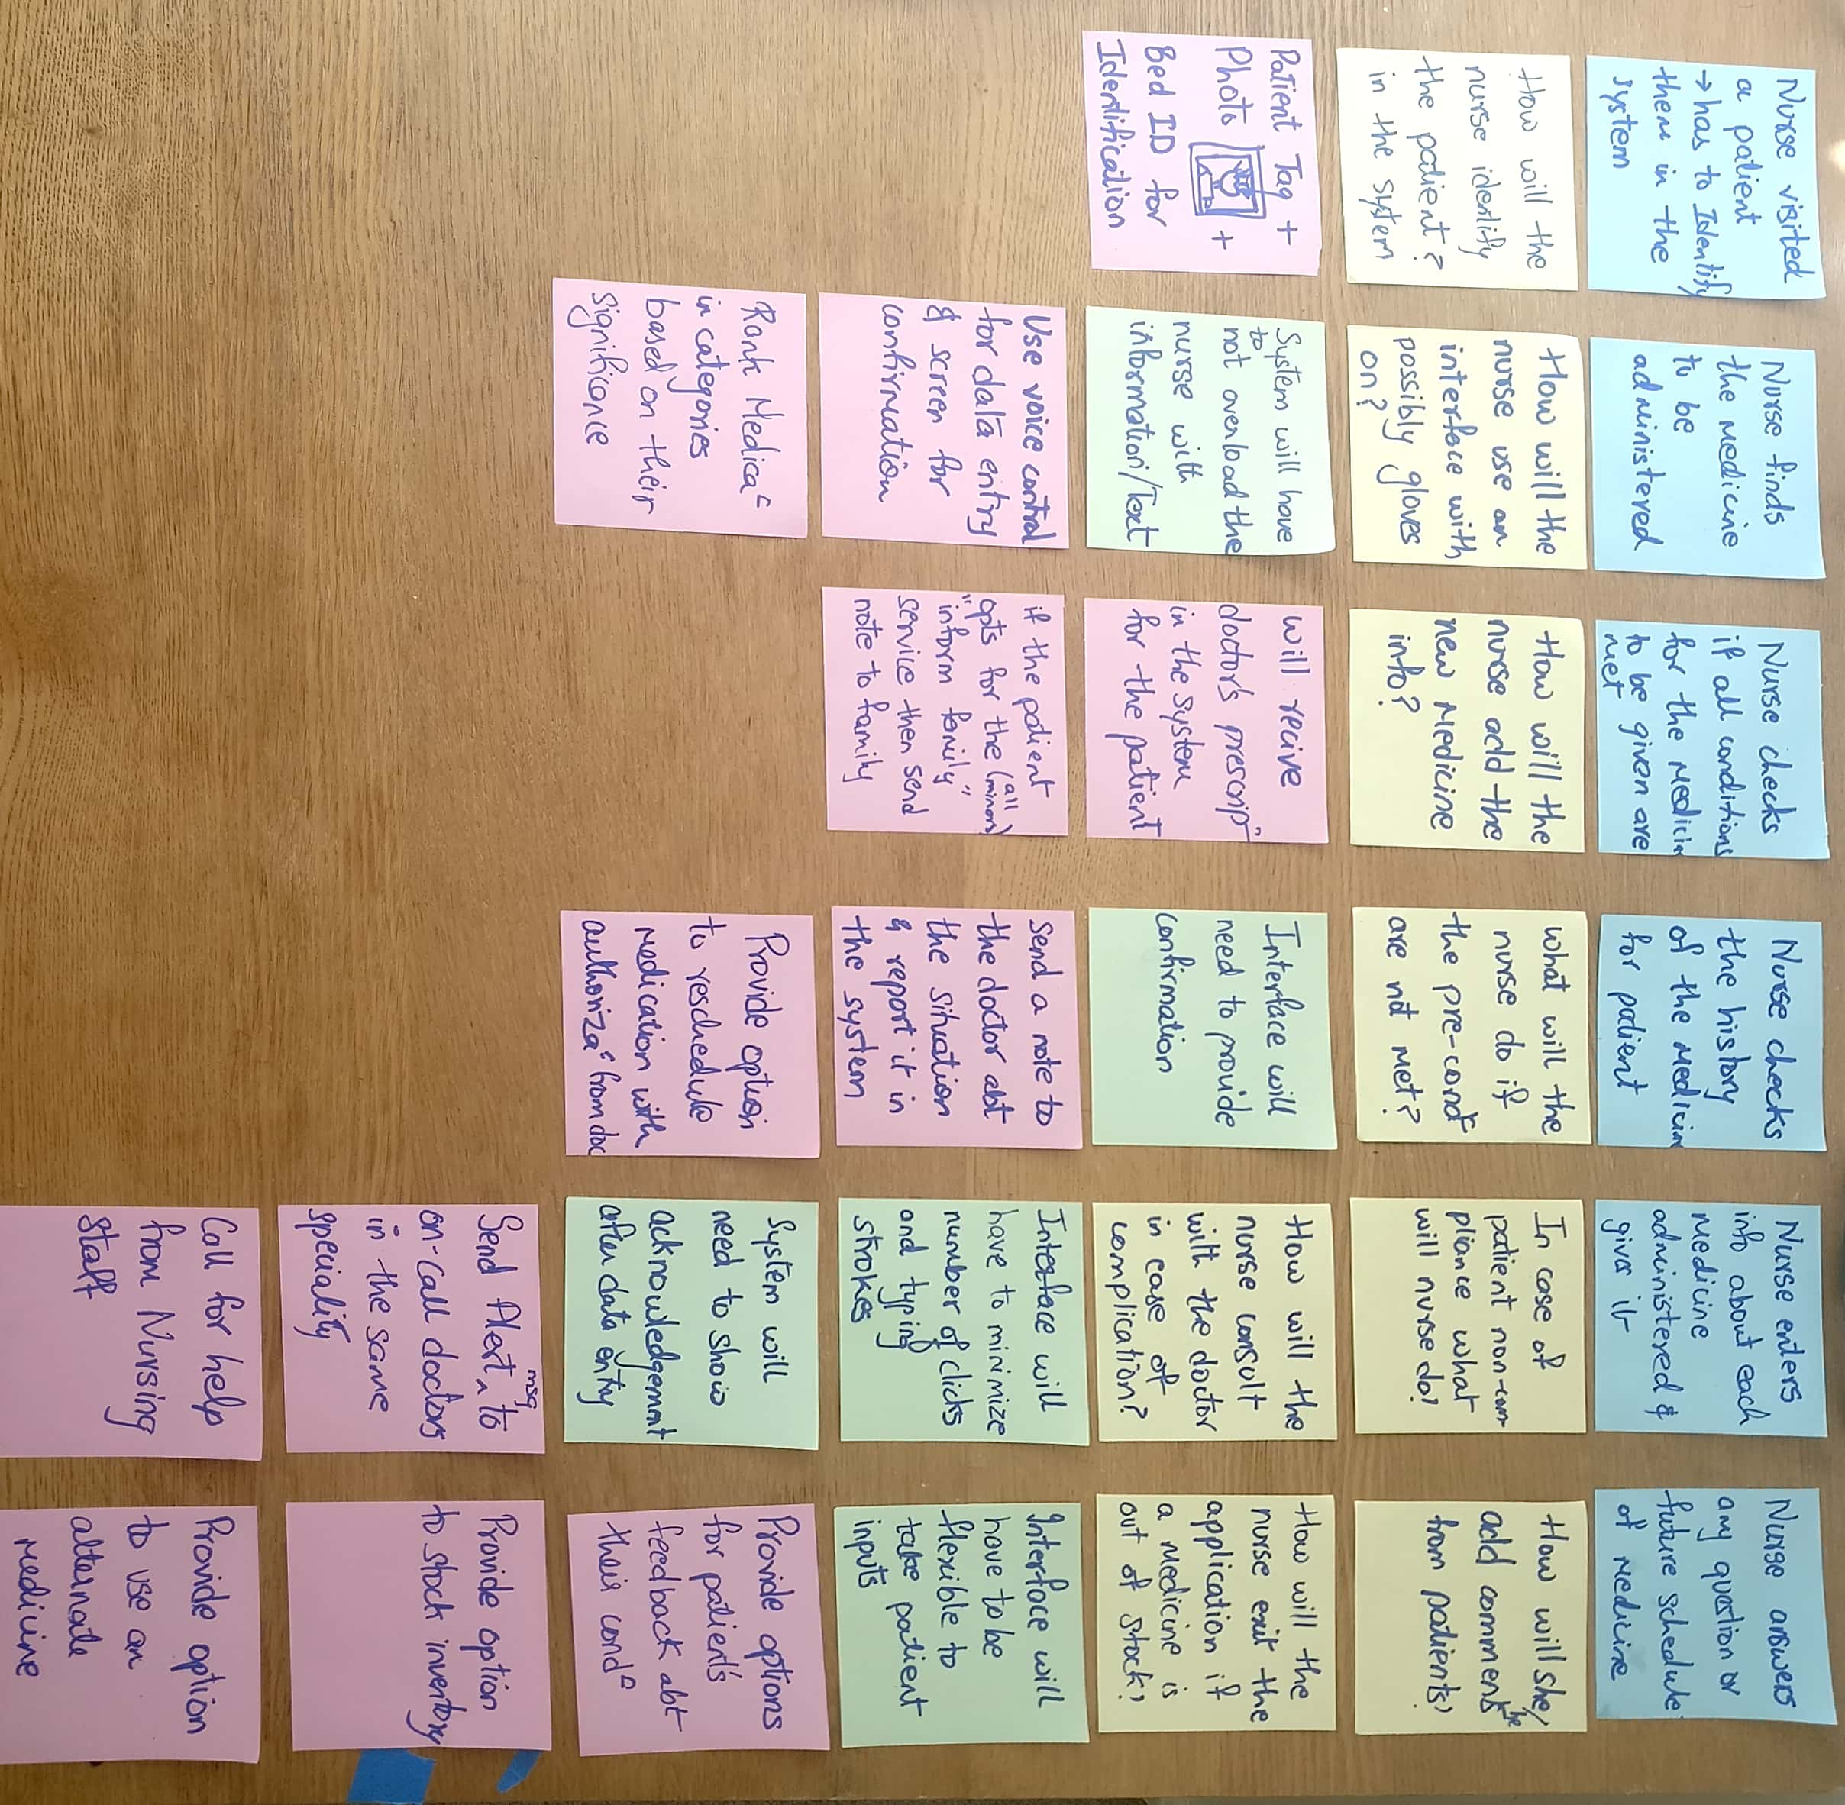

**Background Research and strategies:**

1. Use Tablet app as it is dimensionally close to a paper size which is similar to paper and file system. Familiarity will improve speed of use and make handling the device easier.
2. Provide large buttons,Cloud storage
3. Be everywhere, easy sharing

Define Phase:

1. Use tabs- medications, reports, settings for easy system visibility and navigation
2. Under medication, provide top level options of save, delete, clear, print, close.
3. One screen application per visit, minimize navigation.use expandable boxes for categories.
4. Show progress, keep the nurse focused.
5. Use color green and red for buttons
6. Add to original data about patient, do not generate new records, maintain data quality by keeping all data related to patient under one ID

Design Phase:

* Workflow diagram   
  Link

<https://www.draw.io/?lightbox=1&highlight=0000ff&edit=_blank&layers=1&nav=1&title=Workflow_diagram#Uhttps%3A%2F%2Fdrive.google.com%2Fa%2Fterpmail.umd.edu%2Fuc%3Fid%3D1i9pGNQx3gpfQfNZ-DDITlEiBHwKswRf-%26export%3Ddownload>

*Created using Draw.io*

* High Fidelity Prototype

Link:<https://xd.adobe.com/view/e669b300-8afa-477b-882c-b7a4dedbd213>

The prototype contains a series of screens with clickable areas defined on them to make transactions to the next screens. The clickable areas are highlighted in blue by adobe XD software.

*Created using Adobe XD*

